1. Create a one-paragraph conclusion of what you have learned during the lab today.

Today I learned how to configure html elements using css. In addition, I learned how to put an element using the fragment modifier. Also today, I learned other elements that are useful to configure menu and organize images. One element that I liked is the modified block that initially formats all elements with a square.

2. Write the CSS for an id with the following characteristics: fixed position, light gray background color, bold font weight, and 10 pixels of padding.

#someid {

background-color: #D3D3D3;

position: fixed;

font-weight: bold;

padding: 10px;

}

3. Write the CSS for a class that is relatively positioned. This class should appear 15 pixels from the left. Configure the class to have a light-green background.

.anotherid {

position: relative;

display: 15px left;

background-color: #d3d3d3;

}

4. Google CSS page layout tutorials and find out one CSS technique which is not covered in this and previous chapters. Create a web page to provide the URL of the tutorial, the name of the website and description of the new technique.

**Three column layout**

/* Create three equal columns that floats next to each other */

.column {

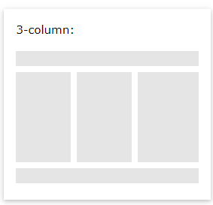 float: left;

width: 33.33%;

}

/* Clear floats after the columns */

.row:after {

content: "";

display: table;

clear: both;

}

@media screen and (max-width: 600px) {

.column {

width: 100%;

}

}

It is another example of web layout well to develop my own Web Page project.

<https://www.w3schools.com/css/tryit.asp?filename=trycss_website_layout_blog>

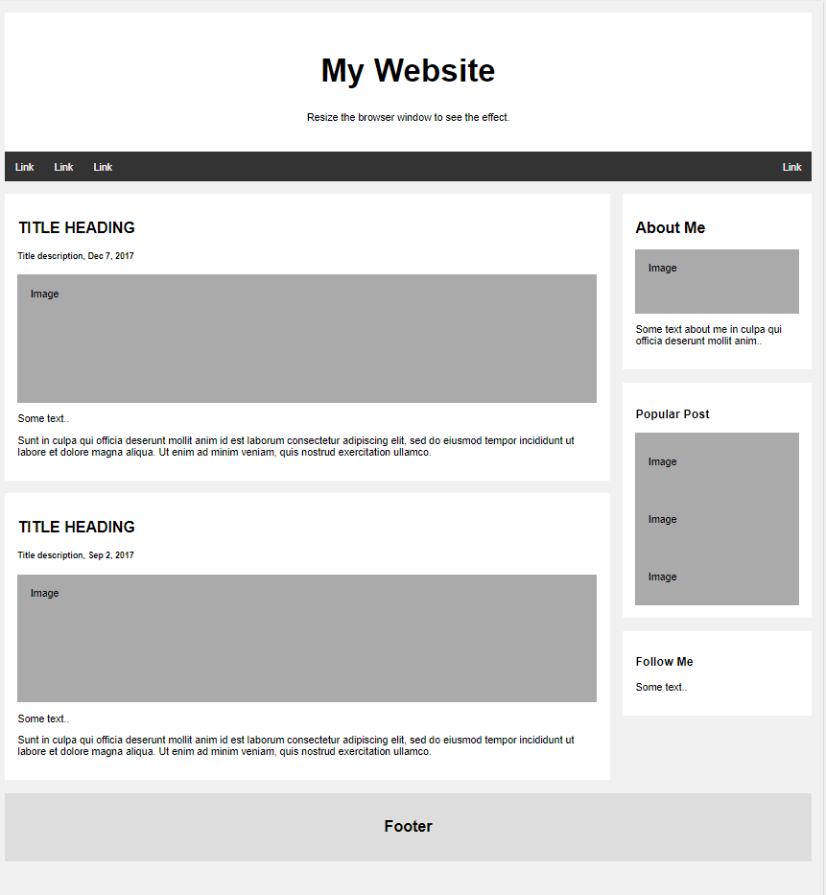

CSS Code

<style>

* {

box-sizing: border-box;

}

body {

font-family: Arial;

padding: 10px;

background: #f1f1f1;

}

/* Header/Blog Title */

.header {

padding: 30px;

text-align: center;

background: white;

}

.header h1 {

font-size: 50px;

}

/* Style the top navigation bar */

.topnav {

overflow: hidden;

background-color: #333;

}

/* Style the topnav links */

.topnav a {

float: left;

display: block;

color: #f2f2f2;

text-align: center;

padding: 14px 16px;

text-decoration: none;

}

/* Change color on hover */

.topnav a:hover {

background-color: #ddd;

color: black;

}

/* Create two unequal columns that floats next to each other */

/* Left column */

.leftcolumn {

float: left;

width: 75%;

}

/* Right column */

.rightcolumn {

float: left;

width: 25%;

background-color: #f1f1f1;

padding-left: 20px;

}

/* Fake image */

.fakeimg {

background-color: #aaa;

width: 100%;

padding: 20px;

}

/* Add a card effect for articles */

.card {

background-color: white;

padding: 20px;

margin-top: 20px;

}

/* Clear floats after the columns */

.row:after {

content: "";

display: table;

clear: both;

}

/* Footer */

.footer {

padding: 20px;

text-align: center;

background: #ddd;

margin-top: 20px;

}

/* Responsive layout - when the screen is less than 800px wide, make the two columns stack on top of each other instead of next to each other */

@media screen and (max-width: 800px) {

.leftcolumn, .rightcolumn {

width: 100%;

padding: 0;

}

}

/* Responsive layout - when the screen is less than 400px wide, make the navigation links stack on top of each other instead of next to each other */

@media screen and (max-width: 400px) {

.topnav a {

float: none;

width: 100%;

}

}

</style>